Group name SW 918B

Name Shinetsetseg

Date : 2022.05.07

Q. 1 Write a C++ program using Switch case to add, subtract, multiply and divide two numbers.

Q. 2 Write a C++ program to convert a binary number to a decimal number.

(0100010) = 66 **// decimal is 34**

Q. 3 Write a C++ program to add two dimensional matrices.

Q. 4 Write a C++ program to accept and display employee details using structures.

Q. 5 Write a C++ program to check whether a given number is a palindrome or not.

Q. 6 Write a C++ program to calculate volume of cube, cylinder and rectangle using function.

Q. 7 Write a C++ program to sort an array in ascending order.

Q. 8 Given two arrays, 1,2,3,4,5 and 2,3,1,0,5 find which number is not present in the second array.

Q. 9 Write a program to create and pint link list using pointers.

File name : your name + CPP.doc

Raj CPP.doc

**Q1**

int main() {

int a,b,c,n;

cout << "Input number 1 ";

cin >> a;

cout << "Input number 2 ";

cin >> b;

cout << "Input math operator 1(+), 2(-), 3(*), 4(/) ";

cin >> n;

switch (n)

{

case 1:

c = a + b;

break;

case 2:

c = a - b;

break;

case 3:

c = a * b;

break;

case 4:

c = a / b;

break;

}

cout << "Result is " << c;

return c;

}

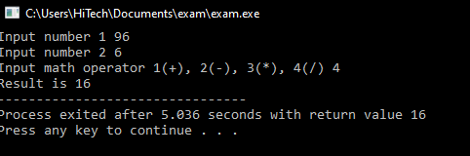

**Q2**

#include <iostream>

using namespace std;

int pow(int n, int x)

{

int t = 1;

for (int a=1; a<=x; a++) {

t = t * n;

}

return t;

}

int main() {

int n, i, decimal= 0;

for (i = 6; i >= 0; i--) {

cout << "Input binary number one by one ";

cin >> n;

if(n != 0) {

decimal = decimal+ pow(2, i);

}

}

cout << "Result is " << decimal;

return decimal;

}

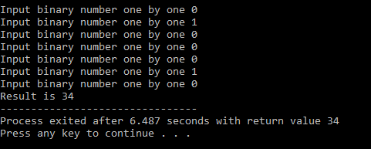

**Q3**

#include <iostream>

using namespace std;

int main() {

int a[3][4] = {{1,2,3,10},

{4,5,6,12},

{7,8,9,11}};

int b[3][4] = {{1,2,3,10},

{4,5,6,12},

{7,8,9,11}};

int c[3][4] = {};

int row,column;

for (row=0; row<3; row++)

{

for (column=0; column<4; column++)

{

c[row][column] = a[row][column] + b[row][column];

cout<<c[row][column]<<"\t";

}

cout<<"\n";

}

return 0;

}

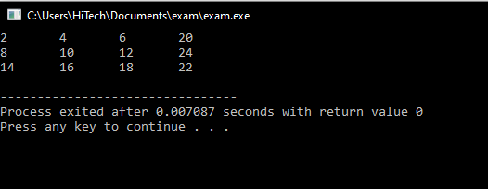

**Q4**

#include <iostream>

using namespace std;

struct employee {

int id;

string name;

string job;

int salary;

};

int main() {

struct employee employer;

cout << "Employee id --> ";

cin >> employer.id;

cout << "Name --> ";

cin >> employer.name;

cout << "Job --> ";

cin >> employer.job;

cout << "Salary --> ";

cin >> employer.salary;

cout<<"Saved \n\n";

cout<<"\nID: "<< employer.id;

cout<<"\nName: "<< employer.name;

cout<<"\nJob: "<< employer.job;

cout<<"\nSalary: "<< employer.salary;

return 0;

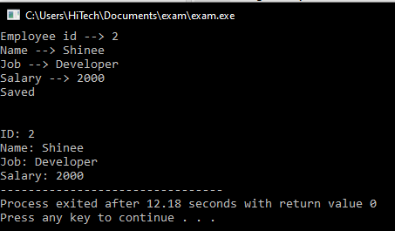}

**Q5**

#include <iostream>

using namespace std;

int main()

{

int n,a,t,temp;

cout<<"Enter N ";

cin>>n;

temp = n;

t = 0;

while (n!=0)

{

a=n%10;

n=n/10;

t=t*10 + a;

}

if (temp == t)

cout<<"Palindrome number "<<t;

else

cout<<"Not palindrome";

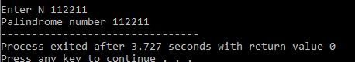}

**Q6**

#include <iostream>

using namespace std;

int volumeCube(int length){

return length * length * length;

}

int volumeRectangular(int length, int width, int height){

return length * width * height;

}

float volumeCylinder(float radius, float height){

return 3.14 * radius*radius * height;

}

int main(){

int cubeLength = 10;

int recLength = 5;

int recWidth = 7;

int recHeight = 10;

float cylRadius = 3.0, cylHeight = 6.0;

cout<<"Volume of Cube "<< volumeCube(cubeLength)<<"\n";

cout<<"Volume of Rectangular "<< volumeRectangular(recLength, recWidth, recHeight)<<"\n";

cout<<"Volume of Cylinder "<< volumeCylinder(cylRadius, cylHeight)<<"\n";

return 0;

}

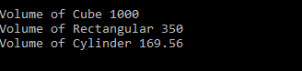

**Q7**

#include <iostream>

using namespace std;

int main(){

int n, a, temp;

int arr[5];

for (n = 0; n < 5; n++){

cout << "Enter the array [" << n + 1 << "] element" << "\n";

cin >> arr[n];

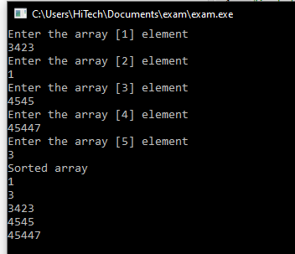 }

for (n = 0; n < 5; n++){

for (a = n; a < 5; a++){

if (arr[n] > arr[a+1]){

temp = arr[n];

arr[n] = arr[a+1];

arr[a+1] = temp;

}

}

}

cout << "Sorted array" << "\n";

for (n = 0; n < 5; n++){

cout << arr[n] << endl;

}

return 0;

}

**Q8**

#include <iostream>

using namespace std;

int main() {

int a[5] = {1,2,3,4,5};

int b[5] = {2,3,1,0,5};

int i, j;

for (i=0;i<5;i++) {

for (j=0;j<5;j++){

if (a[i] == b[j]){

break;

}

if(j==4){

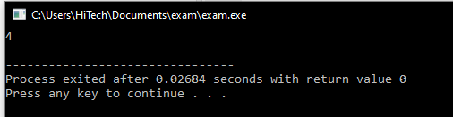 cout<<a[i]<<" ";

}

}

}

cout<<"\n";

return 0;

}

**Q9**

#include <iostream>

using namespace std;

struct node {

int x;

node *next;

};

int main()

{

node *first;

node *conduct;

first = new node;

first->next = NULL;

first->x = 1;

conduct = first;

if ( conduct != NULL ) {

while ( conduct->next != NULL)

conduct = conduct->next;

}

// Creates a node at the end of the list

conduct->next = new node;

conduct = conduct->next;

conduct->next = NULL;

conduct->x = 2;

conduct = first;

//Creates a node at the first

conduct = new node;

conduct->x = 0;

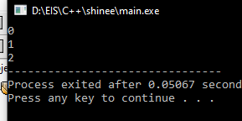 conduct->next = first;

first = conduct;

//Makes sure there is a place to start

if ( conduct != NULL ) {

while ( conduct->next != NULL ) {

cout<< conduct->x<<"\n";

conduct = conduct->next;

}

cout<< conduct->x;

}

}